**APPENDIX K**

**Sample Output**

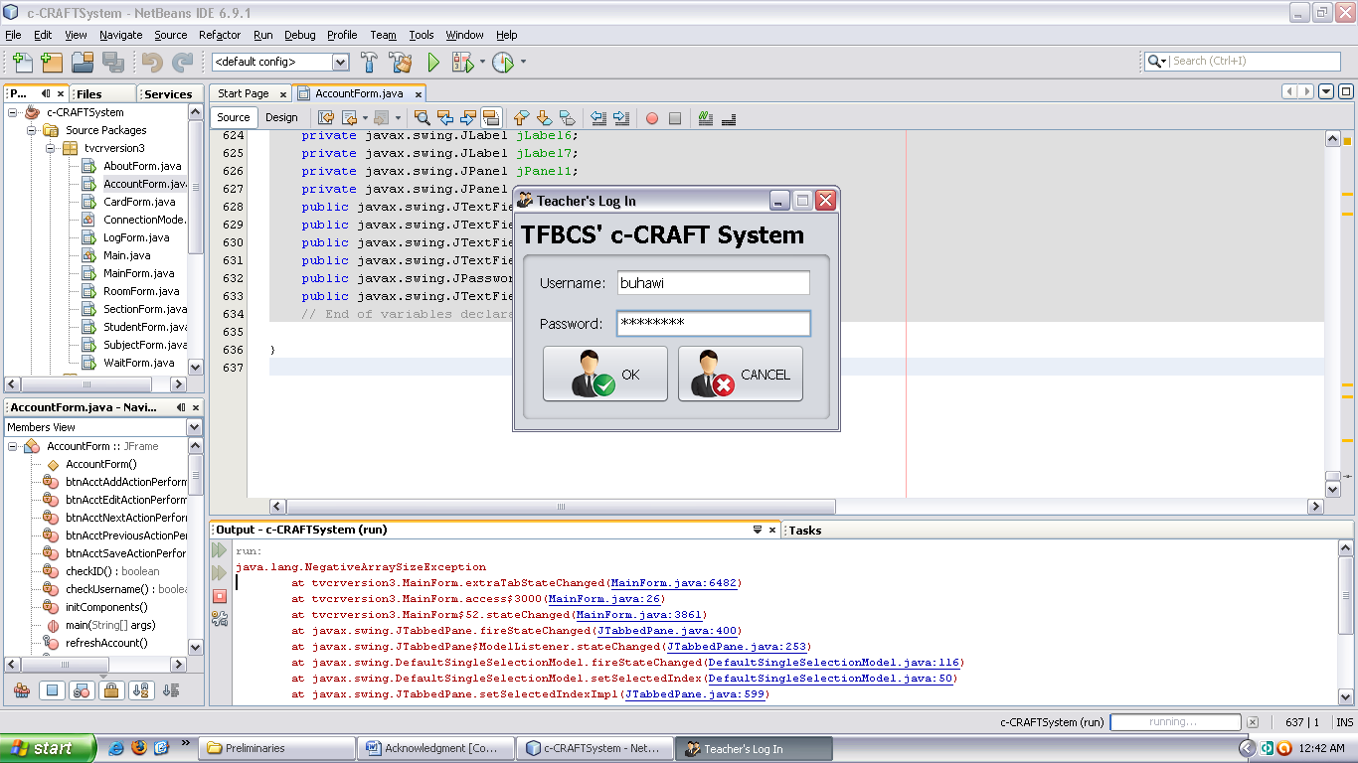

**Teacher’s Log in Window**

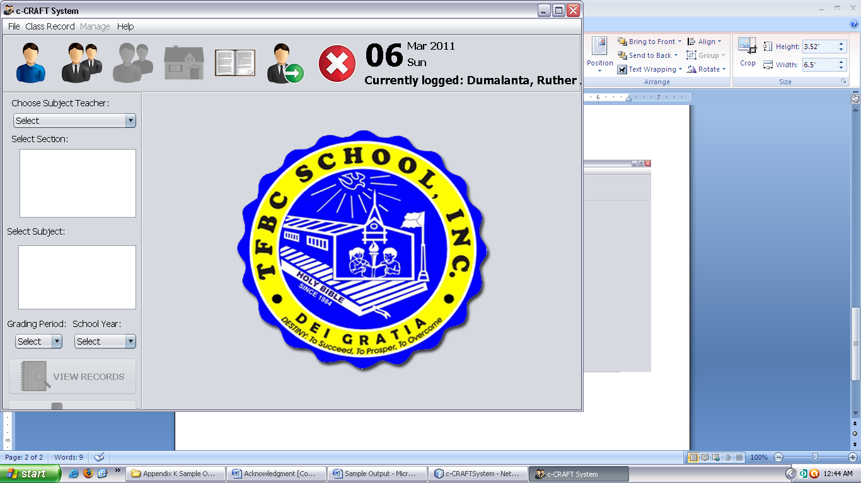

**Main Window**

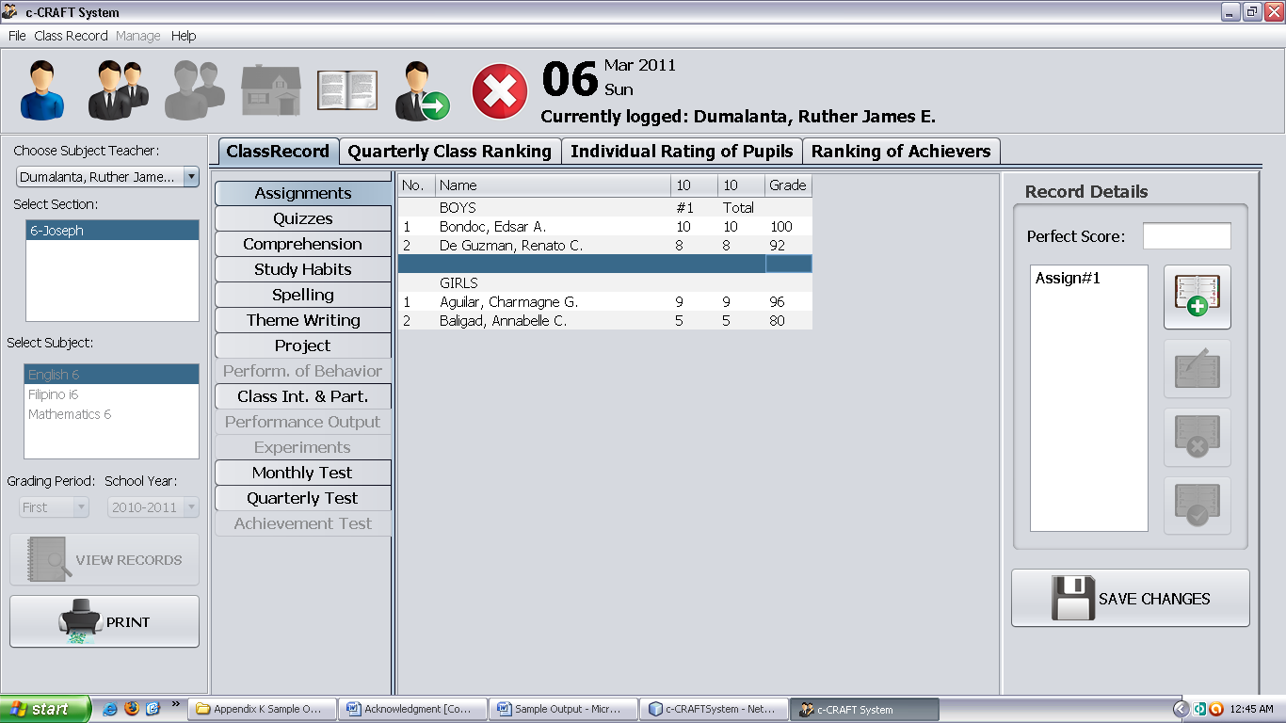

**Class Record View**

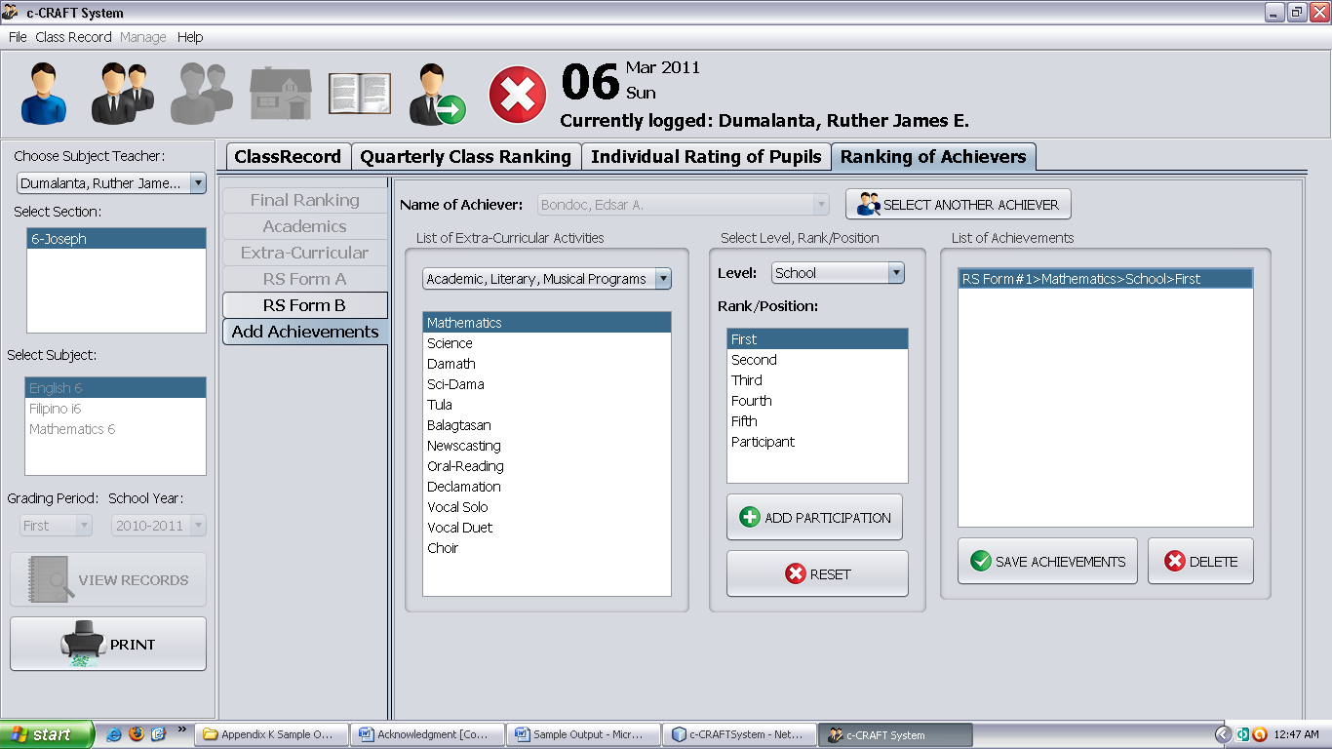

**Ranking of Achievers View**